Managing LinOTP Tokens
This guide explains how to manage your LinOTP tokens using the self-service portal at https://selfservice2fa.visma.com/. LinOTP tokens are primarily used for accessing VPNs (Virtual Private Networks) and AWS (Amazon Web Services). Ensure you log in with the same account you use for the specific service; for example, use your internal account for VPN and your CPA/dev_ account for AWS.

Enrolling a New Token in LinOTP
- After logging in to the self-service portal, navigate to the "Enroll OATH soft token" tab.
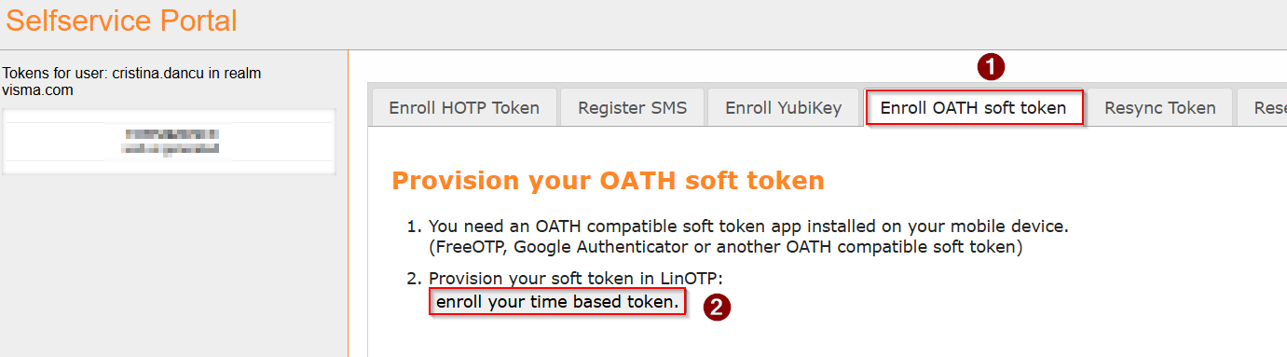
- Click the "enroll your time based token" button.
- Open the Google Authenticator app on your phone, tap the "+" icon, and select "Scan A QR code".
- Scan the QR code displayed on your computer screen.
- Click "Ok".

Deleting an Existing Token in LinOTP
- Go to the "delete Token" tab.
- Select the specific token you wish to delete.
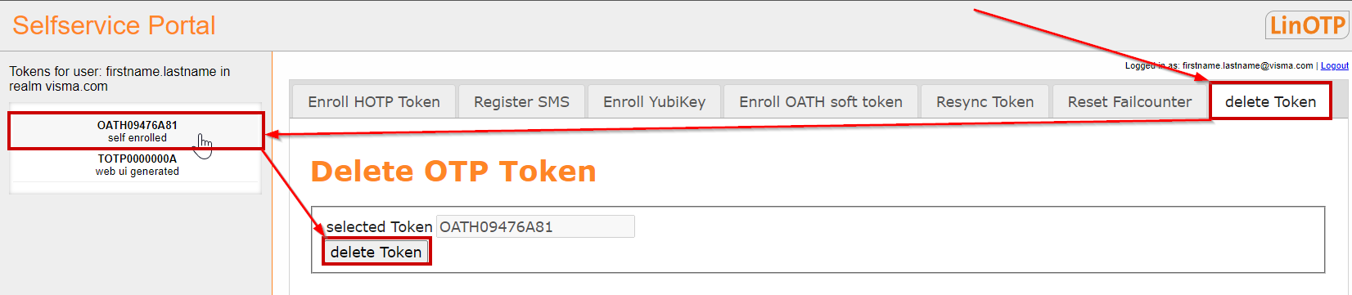
- Click the "delete Token" button.

Resetting the Failcounter in LinOTP
The "Failcounter," a security feature, blocks login attempts after 10 failed tries due to an incorrect user password or token. To resolve this:
- Go to the "Reset Failcounter" tab.
- Select the locked token.
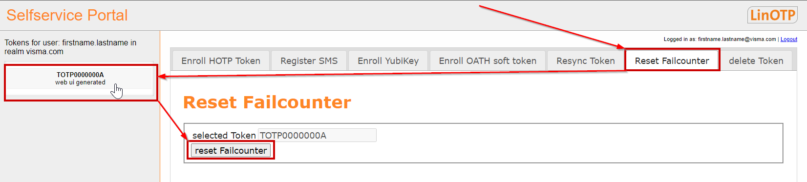
- Click the "reset Failcounter" button.

